King Fahd University of Petroleum & Minerals
College of Computer Sciences and Engineering
Information and Computer Science Department
ICS 202: Data Structures
Second Semester 2007-2008 (071)

Major Examination 2 Time Allowed: 120 minutes.

Student ID & Name:_____________________________________________

Lecture Section:_________________________________________________

Notes:
- Attempt ALL questions.
- Show all details of your answers.
- If you need to make any reasonable assumptions, write them down as part of your answers.

MAKE SURE THE EXAM BOOKLET CONTAINS SIX QUESTIONS IN 13 PAGES. PAGE 12&13 CONTAINS THE REFERENCE SHEET; YOU MAY DETACH THESE LAST TWO PAGES.
Scores:
Questions | Points | Scores
Q1: Part (i) | 22
Q1: Part (ii) | --
Q2 | 10
Q3 | 15
Q4 | 15
Q5 | 10
Q6 | 12
Q7 | 16
Total Score | 100

Q1. [22 Points]
Answer each of the following questions completely but briefly. Each question is worth 2 points unless otherwise noted.
Part (i): Data Structures and Algorithms:

- For the root of a B-Tree of order 5:
  - What is the minimum number of keys: ____.
  - What is the maximum number of keys: _____.

- The BinarySearchTree ordering property can be expressed as: “The key of each node is greater than or equal to the key of its left child, if any, and it is less than or equal to the key of its right child, if any” T / F

- What is the Big-O complexity of the search operation in AVL tree?

- Which of the following is/are minimum binary heap(s)? (4 points)

A  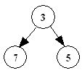 | B  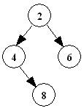 | C  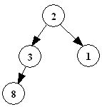 | D  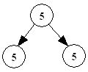

- Why are B-trees more efficient than AVL trees in secondary memory storage?

- The following code-word set is a valid set of Huffman code-words. True or false?
{10, 00, 100, 010, 1101 , 1110}

- The following array represents a MinHeap in which indexes start at 1.

14 | 24 | 34 | 29 | 31 | 38 | 42 | 32

  - What is the key of the parent of the node whose key is 31: _____.

  - What is the key of the left child of the node whose key is 29: ___.

- Suppose a new node having key 27 is added to the heap in the above question. Show the resulting heap as an array.

- Write the depthfirst preorder and depthfirst postorder traversal of the following Binary tree [2 + 2 points]:
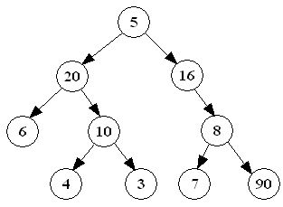

Preorder traversal
Postorder traversal

Q2. [10 points]
The running time T(n) of a method g(n) is represented by the following recurrence relations:
$T(n)=\begin{aligned}\left\{an=1{}^{}{}^{}\text{or}{}^{{}^{}}n=3 | \right.\end{aligned}$

where a and c are constants.

Solve the recurrence relations by the iteration method (unrolling and summing) and hence determine the big-O complexity of g(n). The following are useful summation formulae:

$$\sum_{i=1}^{n}{i=\frac{n(n+1)}{2}}$$ | $$\sum_{i=1}^{n}{i^{2}}=\frac{n(n+1)(2n+1)}{6}$$ | $$\sum_{i=0}^{k−1}{\frac{1}{2^{i}}}=2−\frac{1}{2^{k−1}}$$ | $$\sum_{i=0}^{k−1}{x^{i}}=\frac{x^{k}−1}{x−1}$$  if x ≠ 1

Note: Assume that n is a multiple of 3, i.e. n = 3^{k}

Q3. [15 points: 10 + 5]

- Suppose we define a one-child node as a node with one non-empty child. Write a recursive instance method public int countSpecial(Comparable targetKey) of the BinarySearchTree class that counts the number of one-child nodes in the right subtree of the node with key targetKey. Your method must throw an IllegalArgument exception if targetKey is not found or if the right subtree of the node with targetKey is empty.

Your method may call another private recursive method.

Your method(s) must not use loops, iterators, instance or static variables, or any method of the BinaryTree or BinarySearchTree classes except getKey( ), isLeaf( ), isEmpty( ), getLeftBST( ), and getRightBST( ).

- Suppose the following is an instance method of the BinaryTree class:

public void myTraversal(){
if(! isEmpty()){
right.myTraversal();
System.out.print(key + “ ”);
left.myTraversal();
}
}

What is the output of:

tree.myTraversal();

if tree is the following BinaryTree?

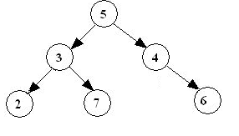

Q4. [10 + 5 points]
- The BinaryHeap class implements a min-heap by using a Comparable array with indexes that start at 1. Write an iterative instance method:
public int Question4()
of the BinaryHeap class that will count all those nodes that have left child less than the right child. The method should return this count.

For example, if the BinaryHeap is representing the following binary tree, the result of the method call with return 2 because only node 5 and 10 have left child less than the right child.
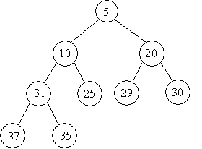

- Draw the resulting binary heap tree when the following numbers are inserted in a min-heap, Top-Down:
12, 7, 15, 3, 5, 10, 2, 4

Q5. B-Trees [10 points: 5 + 5]
- [5 points: 2 + 3] Draw the intermediate and final B-tree when the keys 33 and then 10 are inserted, in this order, in the B-Tree of order 3 given below. [Note: The second insertion is to be done on the B-tree modified by the first insertion]
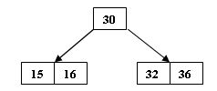

- [5 points: 2 + 3] Draw the intermediate and final B-tree when the key 210 and then 10 is deleted from the following B-tree of order 5: [Note: The second deletion is to be done on the B-tree modified by the first deletion]
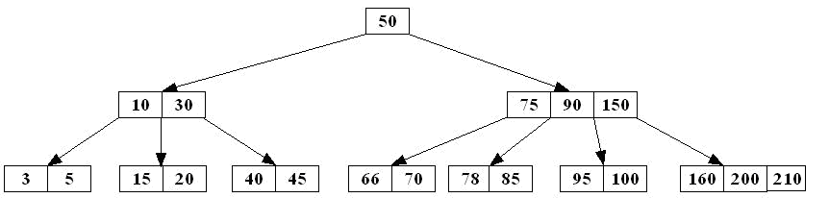

Q6. [12 points: 6 + 6]

(a) Draw all intermediate and the final AVL tree, and mention the type of rotations, when
the key 6 and then 1 are inserted in the following AVL tree:
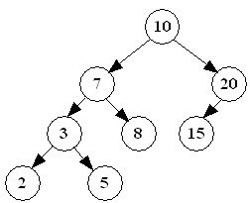

(b) Consider the following AVL tree:

Note: Each of the following questions is to be answered using the original AVL tree given above.

- What is the maximum integer key that when inserted will cause a single right rotation?

- What is the minimum integer key that when inserted will cause a double left-right rotation?

Q7. Huffman Algorithm: [16 points]

The following table shows the characters appearing in a file x along with their frequencies:

Character: | A | E | H | L | R
Frequency: | 8 | 3 | 4 | 6 | 2
Codeword:

- [7 points] Draw a Huffman Code tree to encode the file x [following the ICS202 procedure.
Show all steps.

- [2.5 points] Write the Huffman codeword of each character in the above table.

Character | A | E | H | L | R
Frequency | 8 | 3 | 4 | 6 | 2
Codeword

- [0.5 points] Encode the string HALE

- [2 points] Decode the bit-stream 010101011010011 if possible

- [4 points] Calculate the difference in the number of bits between the uncompressed file and the compressed file.
Note:
  - Don’t include the bits required to send the Huffman-code tree in your computations.
  - Show the details of your computations.

Character | A | E | H | L | R | Total
Frequency | 8 | 3 | 4 | 6 | 2
Codeword
bits

ICS 202 – Data Structures
Quick Reference Sheet

public interface Iterator {  boolean hasNext( );  Object next( ) throws NoSuchElementException;  }  public interface Visitor {  void visit (Object object);  boolean isDone( );  }  public interface Container {  int getCount( );  boolean isEmpty( );  boolean isFull( );  void purge( );  void accept (Visitor visitor);  Iterator iterator( );  }  public interface SearchableContainer extends Container {  boolean isMember (Comparable object);  void insert (Comparable object);  void withdraw (Comparable obj);  Comparable find (Comparable object);  }  public class Association implements Comparable  public Association(Comparable key, Object val)  public Association(Comparable key)  public Comparable getKey( )  public Object getValue( )  public void setKey(Comparable key)  public void setValue(Object value )  public int compareTo(Object obj)  public boolean equals(Object obj)  public String toString( )  } | public class MyLinkedList {  public void purge( )  public Element getHead( )  public Element getTail( )  public Element find(Object obj)  public boolean isEmpty( )  public Object getFirst( )  public Object getLast( )  public void prepend(Object obj)  public void append(Object obj)  public void assign(MyLinkedList list)  public void extract(Object obj)  public void extractFirst( )  public void extractLast( )  public String toString( )  public Iterator iterator( )  public final class Element {  public Object getData( )  public Element getNext( )  public void insertAfter(Object obj)  public void insertBefore(Object obj)  public void extract( )  }  }  public interface Stack extends Container {  Object getTop( );  void push(Object obj);  Object pop( );  }  public interface Queue extends Container {  Object getHead( );  void enqueue(Object obj);  Object dequeue( );  }

public class BinaryTree extends AbstractContainer implements Comparable{ public BinaryTree(Object obj, BinaryTree left, BinaryTree right)  public BinaryTree( )  public BinaryTree(Object obj)  public void purge( )  public boolean isLeaf( )  public boolean isEmpty( )  public Object getKey( )  public BinaryTree getLeft( )  public BinaryTree getRight( )  public void attachKey(Object obj)  public Object detachKey( )  public void preorderTraversal(Visitor v)  public void inorderTraversal(Visitor v)  public void postorderTraversal(Visitor v)  public void breadthFirstTraversal(Visitor visitor)  public void accept(Visitor visitor)  public boolean isMember(Object obj)  public int getHeight()  }  public class BinarySearchTree extends BinaryTree {  private BinarySearchTree getLeftBST( )  private BinarySearchTree getRightBST( )  public boolean isMember(Comparable c)  public Comparable find(Comparable c)  public Comparable findMin( )  public Comparable findMax( )  public void attachKey(Object obj)  public void insert(Comparable comparable)  public void withdraw(Comparable comparable)  } | public class AVLTree extends BinarySearchTree {  public AVLTree( )  public int getHeight( )  public void insert(Comparable comparable)  public void attachKey(Object obj)  public Object detachKey( )  }  // implemented by MinHeap  public interface PriorityQueue extends Container{  public abstract void enqueue(Comparable c);  public abstract Comparable findMin( );  public abstract Comparable dequeueMin( );  }

